Chapter 3, Solution 49

Find v_{o} and i_{o} in the circuit of Fig. 3.94.

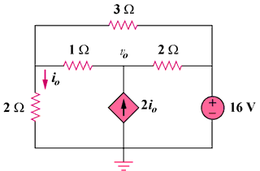

27 V

Figure 3.94
For Prob. 3.49.
–
+

1 Ω

i₁
+
v₀ or
–

+
v₀
–

i₂

2 Ω

27V

2 Ω

(b)

3 Ω

i₁

2 Ω

i₁

i₂

i₃

2 Ω

1 Ω
–
+

27 V

0

i₂

2i₀

(a)

Solution

For the supermesh in figure (a),

3i₁ + 2i₂ – 3i₃ + 27 = 0 (1)

At node 0, i₂ – i₁ = 2i₀ and i₀ = –i₁ which leads to i₂ = –i₁ (2)

For loop 3, –i₁ –2i₂ + 6i₃ = 0 which leads to 6i₃ = –i₁ (3)

Solving (1) to (3), i₁ = (–54/3)A, i₂ = (54/3)A, i₃ = (27/9)A

i₀ = –i₁ = 18 A, from fig. (b), v₀ = i₃–3i₁ = (27/9) + 54 = 57 V.

